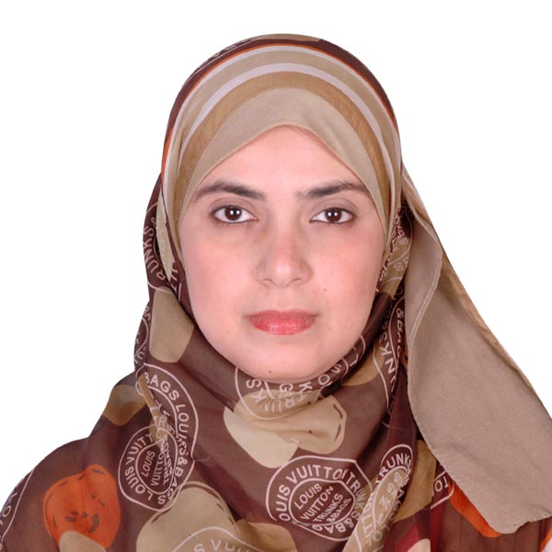
Rehab Hassan Ahmad

PERSONAL INFORMATION

Address Al Azhar square, El Nozha tower, Assiut, Egypt.
Phone +2-088-2148430
Mobile +2-01016809167
Email medicine3005@yahoo.com ,
Nationality Egyptian
Birth Date 29th December 1983.
Marital Status Married
CURRENT WORK:

- Assistant lecturer, Medical oncology department, south Egypt cancer institute, Assuit University, Assiut, Egypt.

EDUCATION:

2013-2020
  - phD medical oncology .
  - Thesis title: The prognostic value of Estrogen Receptor Beta (Erβ) in bladder cancer
2008-2013
- M.Sc. Medical oncology.
  - Overall Grade: Very Good.
  - Thesis title: Retrospective Study of Breast Cancer Patients in South Egypt Cancer Institute From [2005-2010].

2001-2007
- B.Sc. Medicine and surgery.
  - Overall Grade: Excellent with honor.

:
Professional Experiences:

Date 1/11/2020
lecturer of medical oncology/

Department of Medical Oncology , South Egypt cancer Institute, Assuit University, Egypt.

Date 1/3/2013 : Assistance lecturer of medical oncology/

Department of Medical Oncology , South Egypt cancer Institute, Assuit University, Egypt.

Date1/3/2008-29/12/2012 Demonstrator of Medical Oncology

Department of Medical Oncology, South Egypt cancer Institute, Assuit University, Egypt

Abstracts

Anwar Tawfik Amin, Abeer Ibrahim, Rehab Hassan Feasibility of breast conservative therapy in stage III accepted for poster presentation in 5th BGICC,on jan 17-19/2013

Abeer Ibrahim, Mohammed A Salem, Rehab Hassan Breast cancer in young women; disease behavior and management: SECI, 5 year's experience. Accepted for poster presentation in 5th BGICC,on jan 17-19/2013

Languages

- Arabic Native Language
- English Toefl ITP score of (497)

Additional Skills:

International Computer Driving Licence Oct 2004

REFRENCES:

Prof: Ashraf Zedan Abd Alla
Professor of Medical Oncology
Head of Medical Oncology Department
South Egypt Cancer Institute, Assiut University
Egypt.
Email address: profzedan@yahoo.com
:

Dr: myada fawzy seddik
Lecture of Medical Oncolgy
Medical Oncology Department
South Egypt Cancer Institute, Assiut university Egypt
Email address: myadaelzohari@yahoo.com

